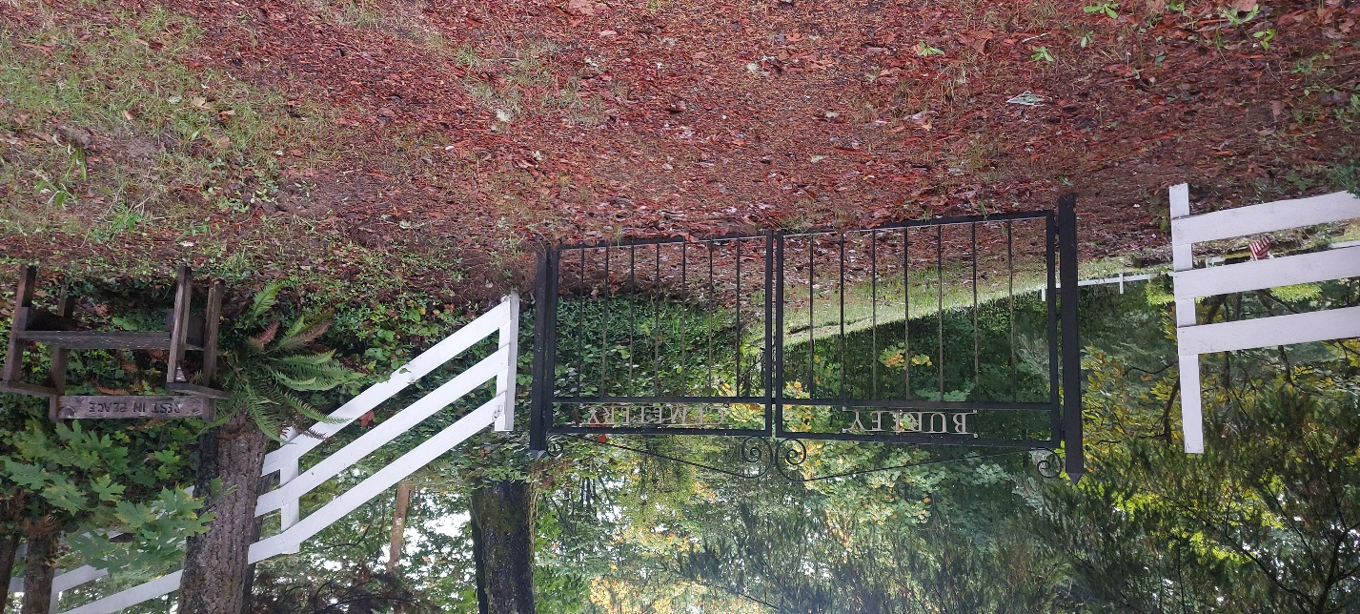
Burley Cemetery – Entrance.

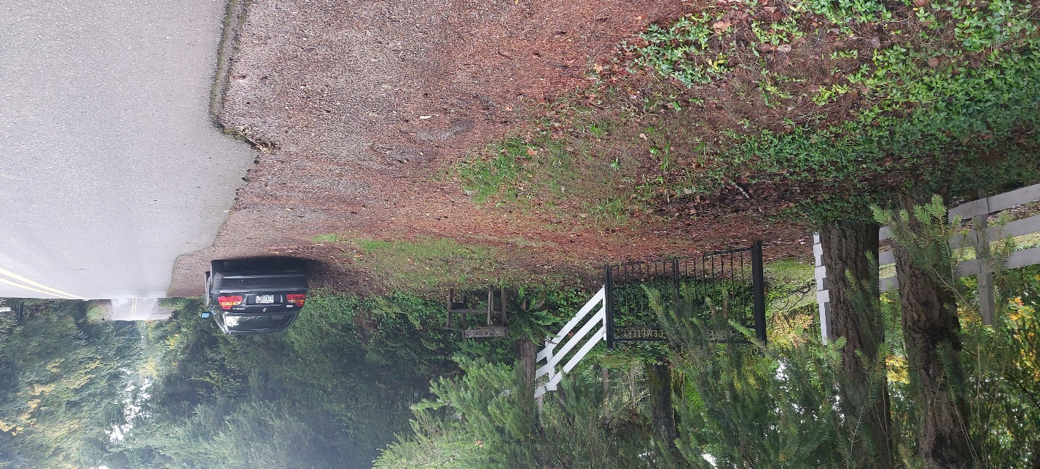
Burley Cemetery – Parking Spot off Willow Road.
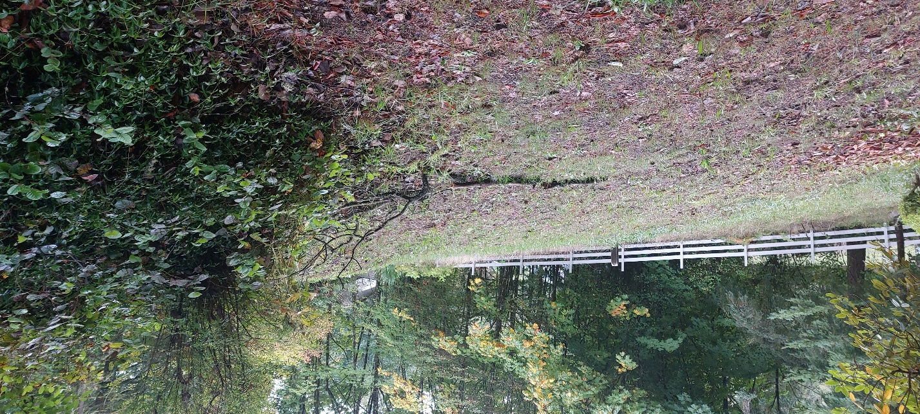
Burley Cemetery – View Looking to the South
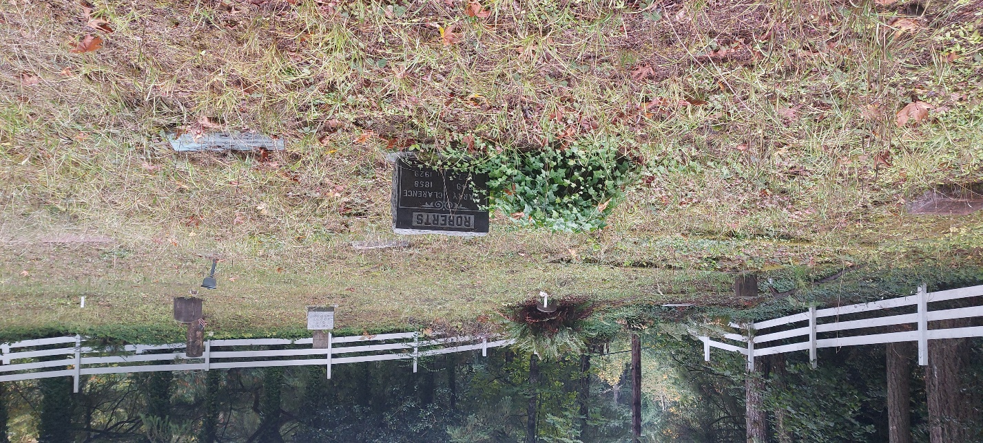
Burley Cemetery – View of SW Corner
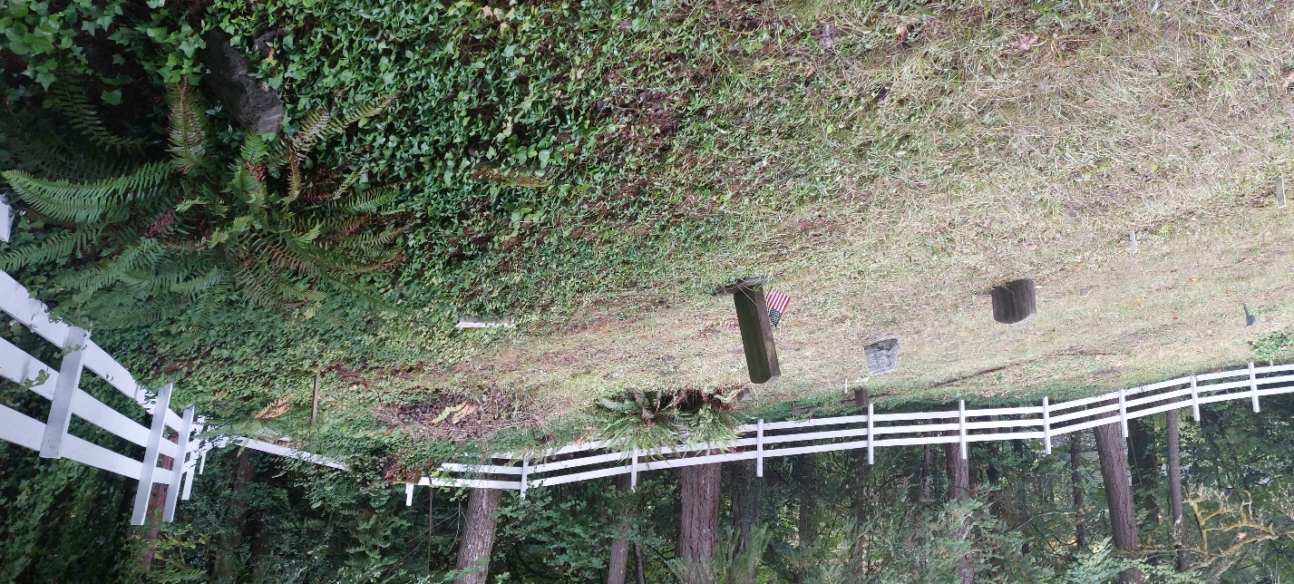
Burley Cemetery – View of SW Corner Looking South
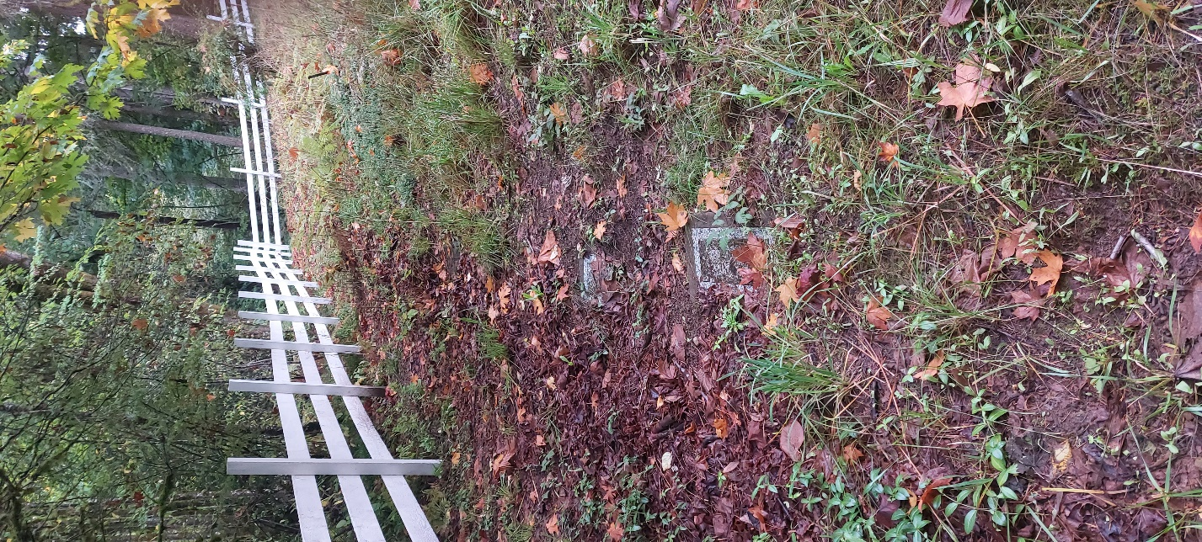
Burley Cemetery – View of East Side
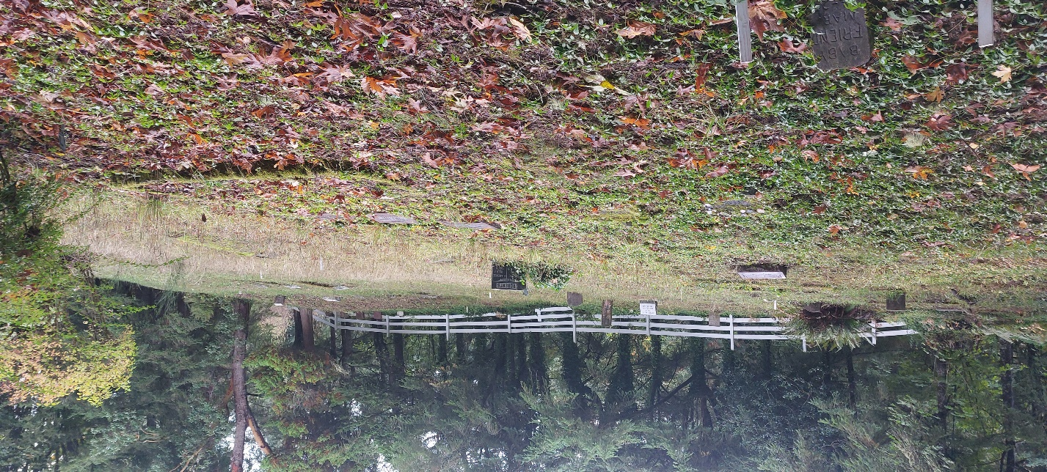
Burley Cemetery – View Looking to the North
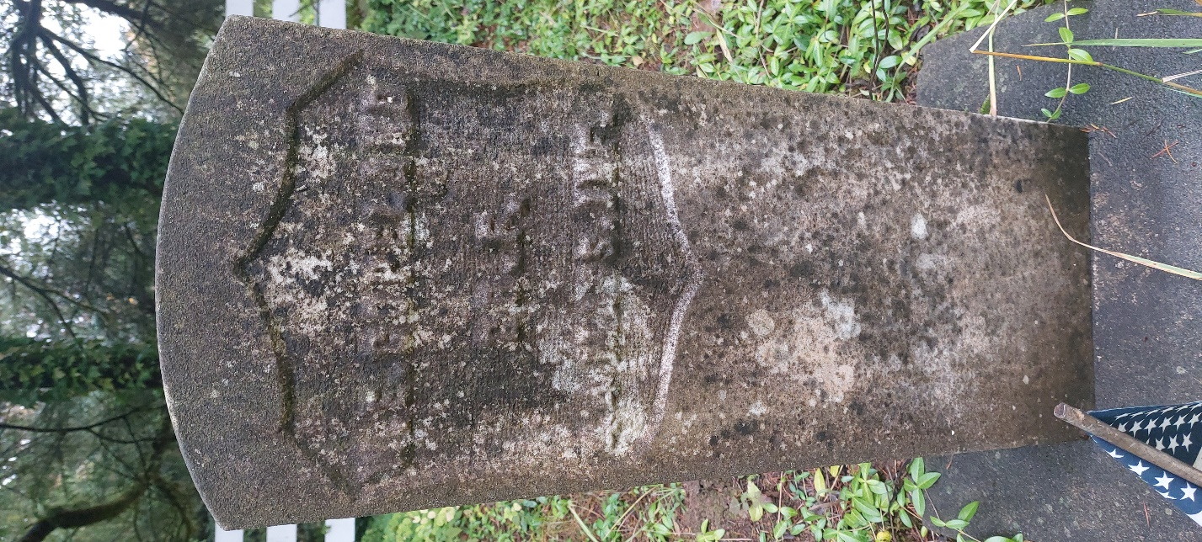
Burley Cemetery – Civil War Veteran Grave
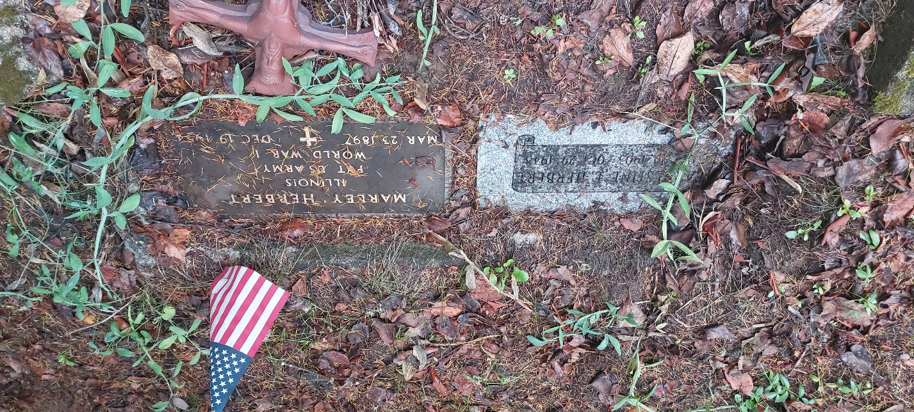
Burley Cemetery – World War Two Veteran Grave
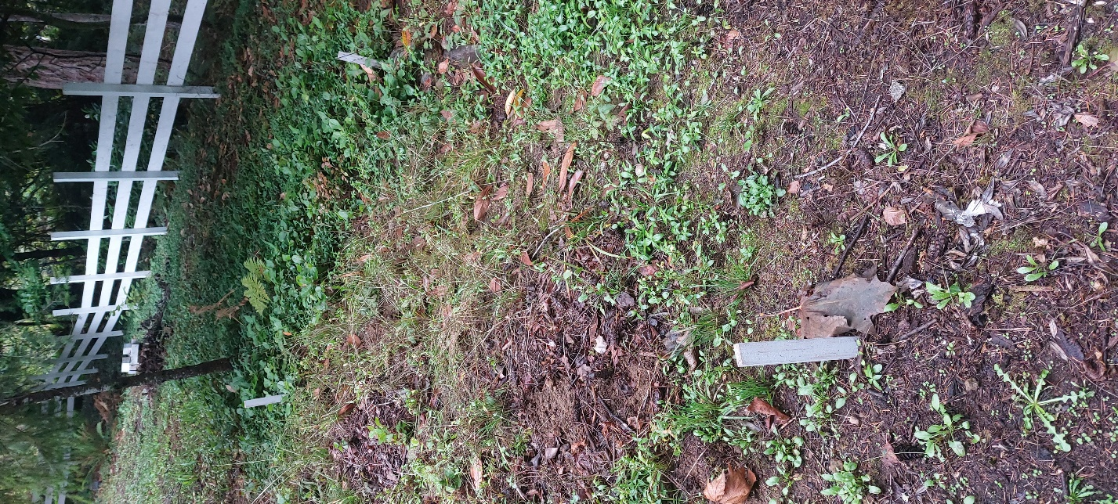
Burley Cemetery – White Stakes Indicate Missing Markers
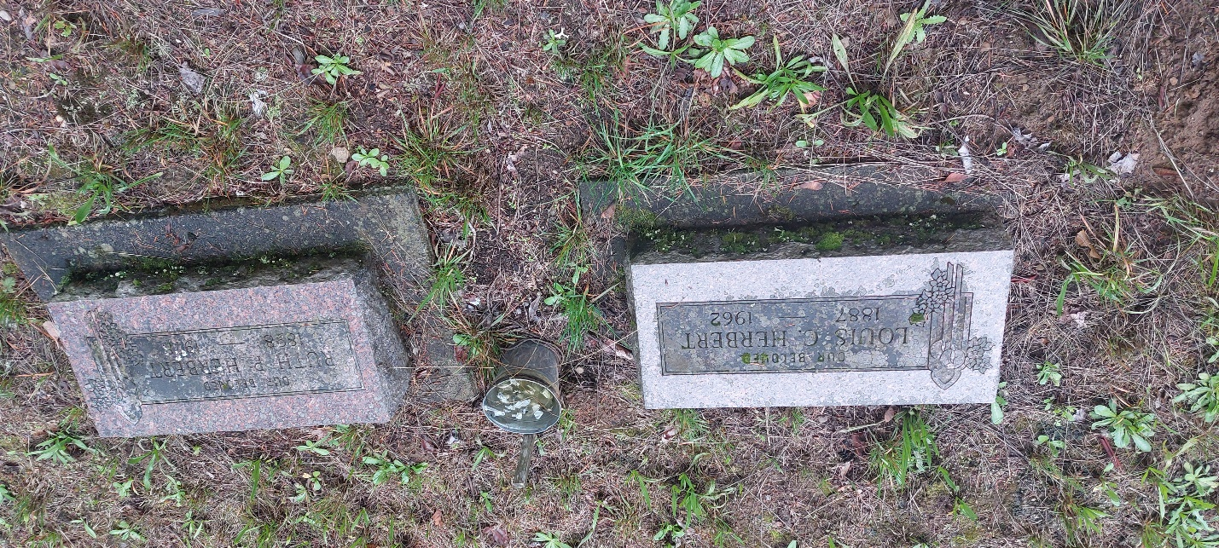
Burley Cemetery – Herbert Family Graves

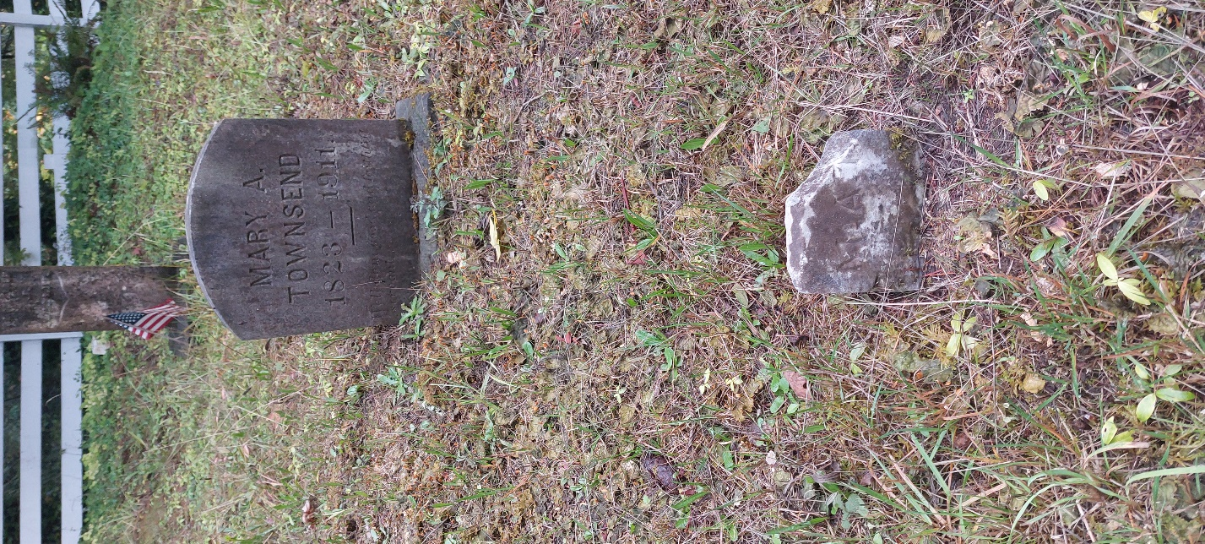
Burley Cemetery – Headstone Examples

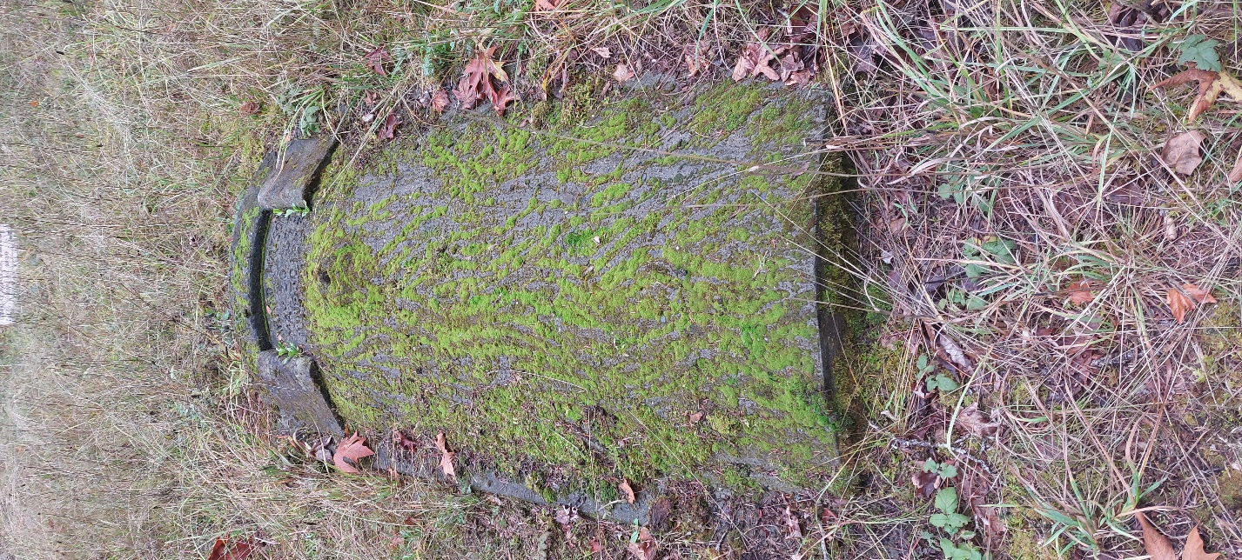
Burley Cemetery - Gravestone
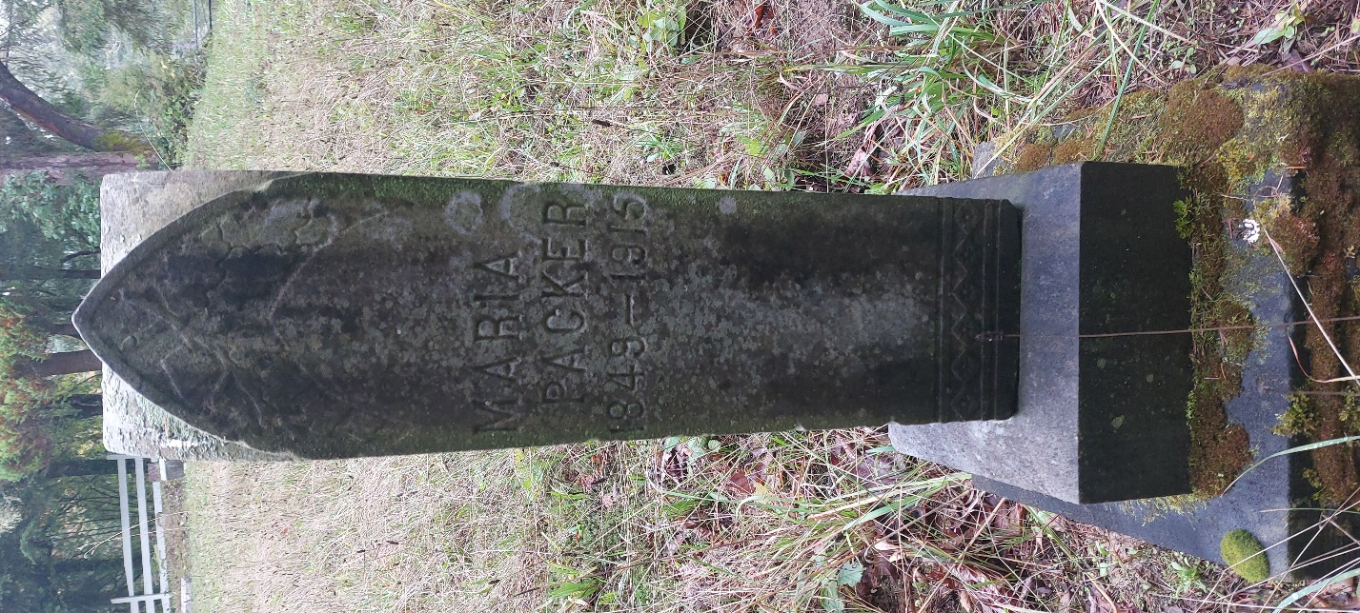
Burley Cemetery – Obelisk Headstone

